Multichannel Recording Protocol

# Pre-requisites

Required Matlab (R2021a) toolboxes: parallel computing toolbox, signal processing toolbox, Statistics and Machine Learning Toolbox

Anaconda (for Phy) (<https://phy.readthedocs.io/en/latest/>)

CUDA 11.0 Toolkit

* <https://www.mathworks.com/support/requirements/previous-releases.html>
* <https://visualstudio.microsoft.com/vs/older-downloads/>

# Running Kilosort

Kilosort is an automated spike-sorting algorithm developed by Cortex Labin UCL at first and later continued by Mouse Lab at Janelia HHMI (Pachitariu, M., Sridhar, S., & Stringer, C. (2023). Solving the spike sorting problem with Kilosort. bioRxiv, 2023-01). Although current versions of Kilosort are designed with Neuropixel Probes in mind, settings can be changed for use with other probes of different configurations.

The current version of Kilosort used in our lab is 2.5, with several modifications of the code to match our recording setups. The mainframe code can be found in our Github (<https://github.com/Sensory-Processing-Lab/Kilosort-LeeLab>). Using the code “master_kilosort_leelab.m”, the user will need to modify variables related to folder paths and datafile names.

The user should also create a new channel map file following the template “makeHarrisChannelMap.m” if using a probe with a different channelmap than those within the current directory.

Once filenames and paths are correct, run the code. It’s advised to run the code section by section, to check for potential errors.

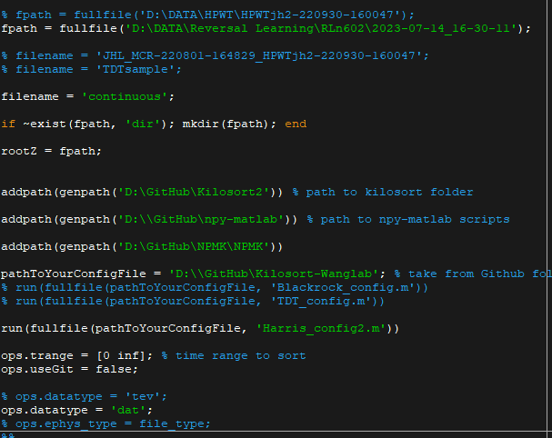

## **Specific directions for using Openephys DAQ board with DBC 64ch probes**

Openephys file paths can be convoluted. “continuous.dat” files containing raw data files are in “FILENAME\Record Node 105\experiment1\recording1\continuous”. We advise users to move the continuous.dat file to the FILENAME directory, and create a folder named “OE_DAQ”. Put timestamps.npy from the previous folder in here. This contains timestamps of events recorded during the experiment, and will be needed later.

# Manual curation: Phy

Open “Anaconda” command prompt. Change the working directory to the folder containing output of kilosort (usually the same folder where the data is in). Write the following command: “phy template-gui params.py.

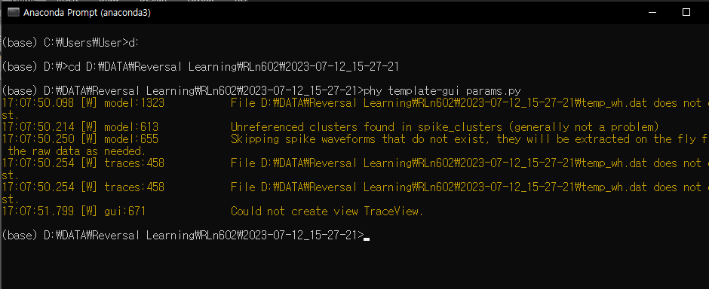

To use Phy, use the following manual: <https://phy.readthedocs.io/en/latest/>

# Post-Analysis, extracting waveforms and spike-times

In this phase, Kilosort and Phy outputs are converted into individual .mat files per sorted neuron. At most 2000 waveforms, best channel, spike-times and stimulus event times are also saved. Lick related analog signal is also separated from the raw data during this processed and saved as “Lick.mat” in the data directory.

In “Kilosort-Wanglab\Analysis_postphy\ana_postPhy.m” Change the information below.

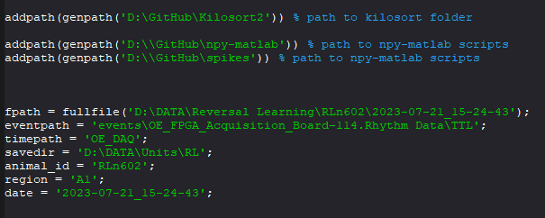

Specific directions regarding OpenEphys (as stated above) must be followed, or the code will not run.

When running the code for the first time for a given animal, the code will create a “animal_id_unit_list.mat” file in the directory “savedir\animal_id”. This is a file that contains general information about saved units regarding this animal (recorded date, animal_id, recorded area etc). On subsequent code runs for other recording sessions, this file will be updated each time.

Saved unit files will also be in the above directory. **For this purpose, spike-sort data from the same animal on one computer only.**

# Edit log

24-11-05 JL: added pre-requisites